**WORKING INSTRUCTIONS**

|  |  |
| --- | --- |
| **Doc Nr.:** | **NCT LAB** |
| **Version:** | **Continental TCI, Bangalore** |
| **Impl. Date:** | **Model:** ¸**HMF2550 Arbitrary Function Generator** |

|  |
| --- |
| **Safety Instructions/ ESD/3S** |
| 1. **Always follow working instruction** 2. **Clean the machine table before usage and clean the equipment if any dirt and dust found.** 3. **After completing the work do not keep the fixtures, test components on the machine table.**  |  |  |  | | --- | --- | --- | | **S1 (Seiri)** | **S2 (Seiton)** | **S3 (Seisou)** | | **Prepare needed tools** | **Keep everything tidy** | **Always keep clean** | |

|  |
| --- |
| **Unusual Case** |
| **If the equipment functions abnormally, e.g. strange sounds, warning signal or something looks unusual:**   |  | | --- | | **Stop machine – Inform - Waiting** |   **Stop the machine**  **Inform to the lab incharge**  **Wait for the decision** |

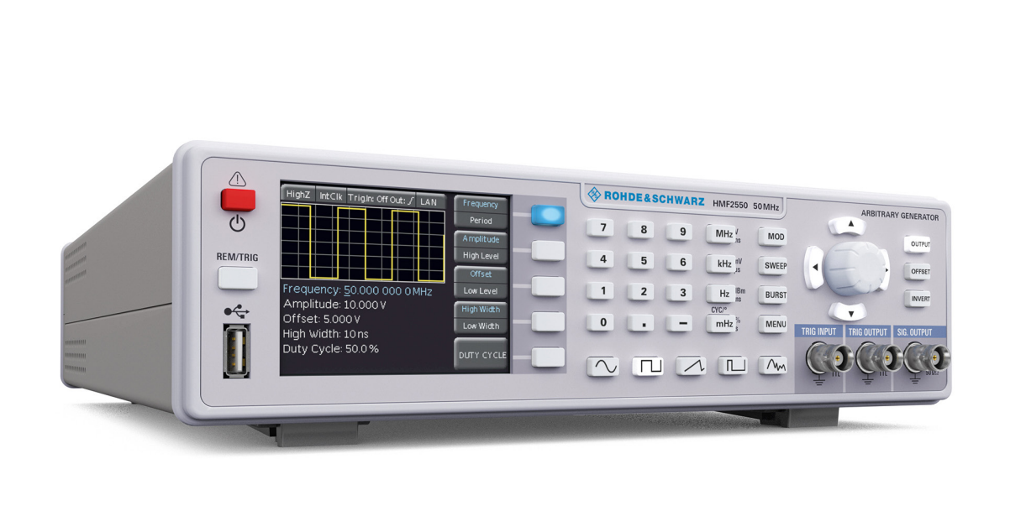

**Safety labels on products:**

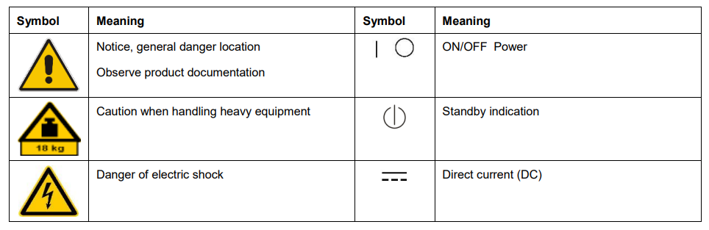

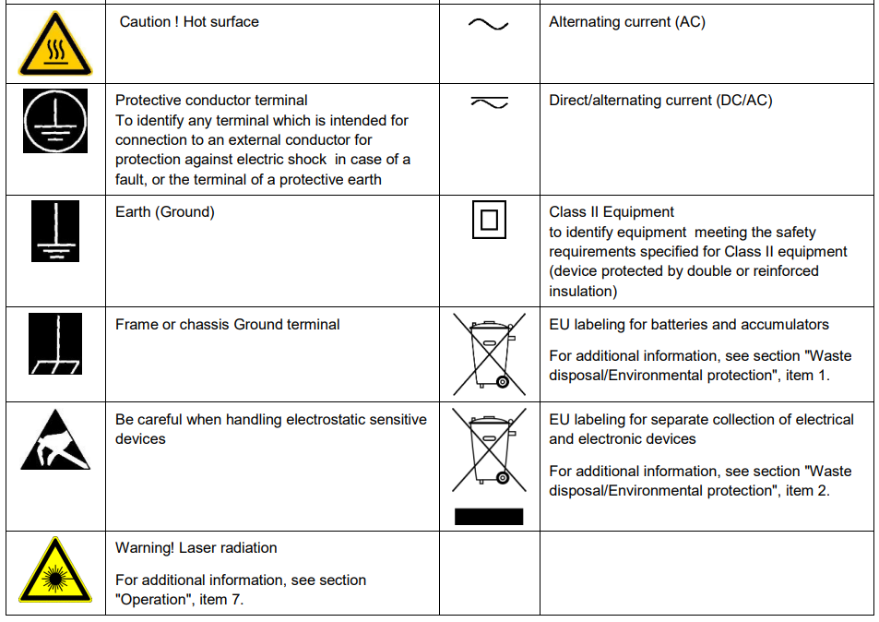

**Risk of instrument damage during operation:**

An unsuitable operating site or test setup can damage the instrument and connected devices. Ensure the following operating conditions before you switch on the instrument:

* Make sure that the nominal voltage setting on the product matches the nominal voltage of the AC supply network.
* Never use the instrument in dusty or damp conditions, in an explosion hazard area, or near aggressive chemicals. The ambient temperature and humidity must not exceed the ranges specified for the equipment.
* The instrument should be dry and shows no sign of condensation.
* The instrument can only be operated with a properly grounded safety socket outlet.
* Never use a cheater plug or other means to defeat or disconnect the protective ground lead.
* Check the power cable for damage and replace it if necessary. The power cord must be plugged in before signal circuits are connected.
* Before each measurement, check the instrument for proper operation using a known signal source or sample.
* Signal levels at the input connectors are all within the specified ranges.
* Signal outputs are correctly connected and are not overloaded.

**Switching on :**

Turn the instrument on by pushing the POWER button 1 . Upon turn-on of the HMF2550 / HMF2525 the display will first show the type of instrument The instrument will resume the operational settings which were active before turn-off. All settings are stored in a non-volatile memory and are recalled when the instrument is switched on. However, the output signal (OUTPUT), the BURST mode, the SWEEP function, the OFFSET and INVERT functions will always be deactivated upon turn-on.

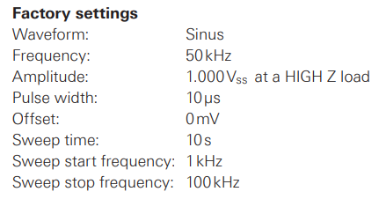

**Supported signal waveforms with parameters:**

The R&S®HMF2525 / R&S®HMF2550 offers five different waveforms with a wide selection of parameters:

(all values in parenthesis [ ] are valid for the R&S®HMF2525)

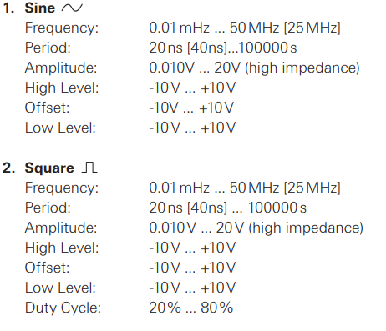

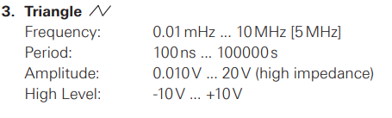

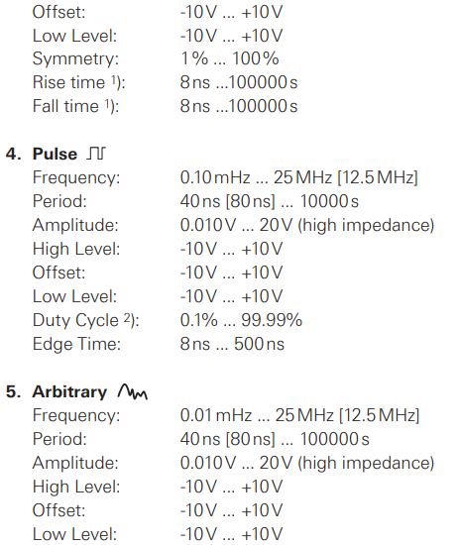

**Modulation types:**

A modulated signal consists of a carrier signal and a superimposed modulation signal. The R&S®HMF2525 / R&S®HMF2550 offers the following types of modulation: AM (amplitude modulation), FM (frequency modulation), PM (phase modulation), PWM (pulse width modulation), and FSK (frequency shift keying). The type of modulation is selected by pushing the MOD key and choosing the modulation type with the knob in the soft menu TYPE. Only one type of modulation may be active at any time. All basic signal function (except the sine function**)** are generated by an internal arbitrary generator. This generator also produces, (except sinusoidal modulation) the modulation types. Internal (Source Int.) or external (Source Ext.) modulation can be chosen.

**Amplitude modulation (AM) :**

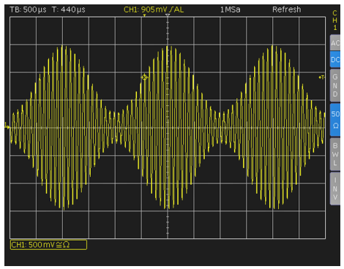

With AM modulation the amplitude of the carrier signal will be changed by the amplitude of the modulating signal. After selecting AM in the soft key menu TYPE the modulation depth can be set from 0% to 100% in 0.1% increments (Depth)

**Frequency modulation (FM):**

With FM modulation the frequency of the carrier signal will be varied according to the instantaneous value of the modulating signal, the amplitude remains unaffected. The Deviation is the maximum frequency deviation of the modulated signal from the carrier frequency

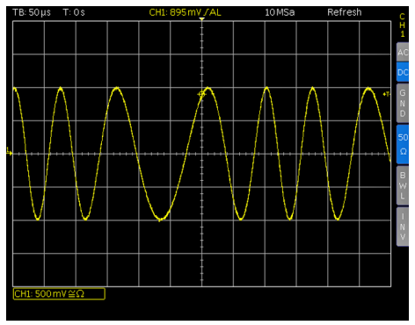

**Phase modulation (PM):**

With PM modulation the phase of the carrier signal will be shifted according to the instantaneous value of the modulating signal. The Deviation describes the maximum deviation of the modulated signal phase from the carrier signal. Values between -180° and 180° can be set by using the knob

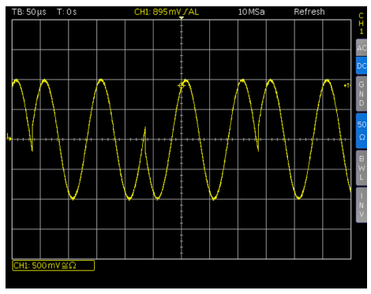

**Front panel of R&S®HMF2550 :**

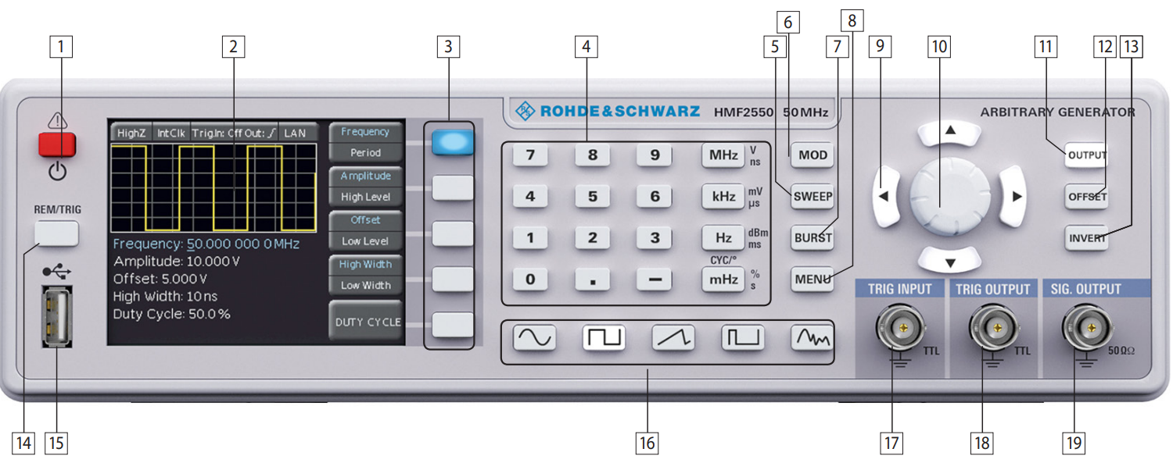

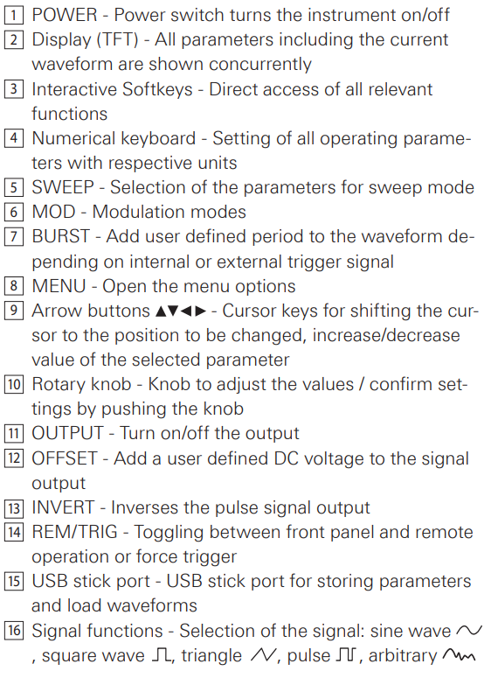

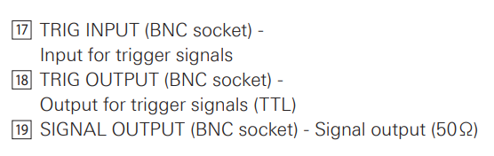

**Rear panel of R&S®HMF2550 :**

